**CSSE3101 – ADVANCED WEB TECHNOLOGIES**

**ACTIVITY 1 – JAVASCRIPT**

Implement the following instructions using the JavaScript Document Object Model.

1. Create a new HTML file named **findgrade.html** with the following design.

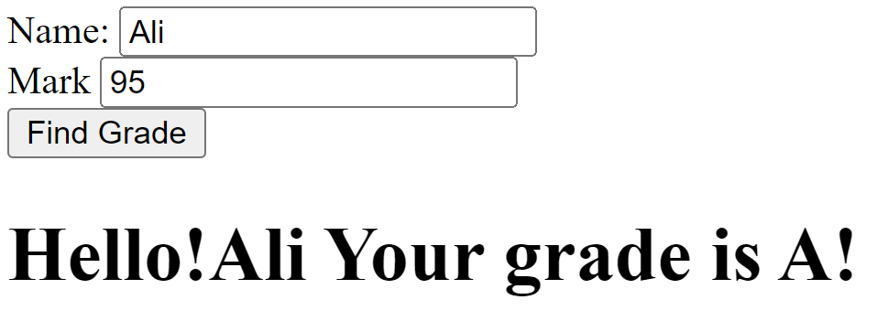

1. Create a JavaScript function called **findGrade()** that is designed to extract a student's name and their corresponding mark from input controls. This function will then determine the appropriate grade for the given mark and display the result within an HTML **<h1>** heading element, as shown in the example provided above.

|  |  |  |
| --- | --- | --- |
| **Grading Scheme** | | |
| Range | Grade | Point |
| 100-90 | A | 4.0 |
| 89-85 | A- | 3.7 |
| 84-80 | B+ | 3.3 |
| 79-76 | B | 3.0 |
| 75-73 | B- | 2.7 |
| 72-70 | C+ | 2.3 |
| 69-67 | C | 2.0 |
| 66-60 | C- | 1.7 |
| 59-55 | D | 1.0 |
| 54-00 | F | 0.0 |